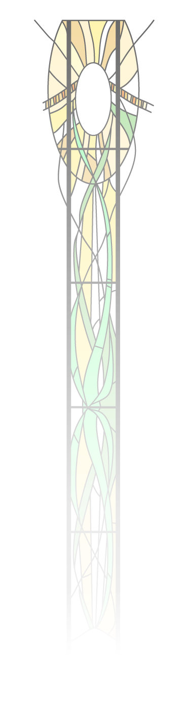 **St Alban’s Catholic High School**



*“Learning, Respecting, Caring”*

**Office Administration Lead**

**Permanent Contract**

Salary: Grade 3 Points 7 to 11: £22,369-£24,054 FTE salary

**£18,422-£19,809 Actual pro-rata**

(2023 Support Staff Pay Award pending)

35 hours per week/40 weeks per year

8.15am – 3.45pm daily

(30mins unpaid lunch)

**Required as soon as possible:**

The Governors are seeking to appoint an enthusiastic and committed individual as the Office Administration Lead. The successful candidate will provide support and advice to ensure the student data held within the school is, appropriate, up-to-date, accurate and available to relevant staff.

The role is to manage the day-to-day running of the School Office and the work of the Administrative Team to ensure the provision of efficient administrative systems and procedures. Working in close liaison with the Headteacher, taking decisions on day-to-day operational matters within guidelines of work plans, policy, procedure etc. Such decisions include planning, and prioritising, allocating and organising work, developing and using new technology, monitoring performance, taking remedial action as required.

St Alban’s Catholic High School strives to provide an excellent education for our students within a caring Christian community where all are respected, valued and supported to achieve their potential.

Visits to the school by potential applicants are welcomed. Please telephone Lisa Gittins, EA to Headteacher, on 01473 726178 to arrange. For an informal conversation about this post, please contact Matt Baker, Headteacher.

All offers of employment will be subject to an Enhanced Disclosure and Barring check, evidence of Right to Work in the UK and satisfactory completion of all other pre-employment checks.

Closing Date**: 02 November 2023 at 10am**

Interviews**:** **W/C 06 November 2023**

**Completed application and disclosure forms to be submitted electronically to:**

[**recruitment@st-albans.suffolk.sch.uk**](mailto:recruitment@st-albans.suffolk.sch.uk)